ME4001 – EXPERIMENT NO. 3 - SPEED CONTROL OF DC MOTOR
Instructors: Murat Umut Yangaz

PLEASE BRING A USB STICK TO THE LAB TO SAVE YOUR DATA

Objectives To identify DC motor parameters using open loop response
To control speed of a DC motor using closed loop (P and PI) controllers.
I. Basic Equations / Theory
1) Mathematical Model of DC Motor
A DC motor is an electromechanical device that outputs speed and torque in response to an input voltage.
A model, by taking speed as the output and voltage as the input, is derived from first principles in the following link [1]. This model consists of two coupled ordinary differential equations (ODEs) (1 from mechanical and 1 from electrical parts) and involves many parameters intrinsic to the motor itself. Usually, if the parameters in the model are known, we can determine the behavior of the system completely. (Parameters may be given in motor data sheet or might be available through direct measurement). As all/most of these parameters are not known to us, we have to apply an alternative method, by lumping parameters together.
2) Transfer Function of DC Motor from Voltage to Speed
By taking Laplace Transform of these 2 ODEs (equations 3 and 4 in [1]) and after some mathematical manipulation we can find the transfer function from input to voltage (equation 7 in [1]). As we have 2 ODEs, the order of the transfer function is 2. Experience has shown that this model can be safely reduced to first order as electrical dynamics is much faster than mechanical ones.
Thus, as a simplified model, we will assume that the transfer function is of first order, instead of two. General form of a first order transfer function is:
$$G\left(s\right)=K\frac{1}{s+1} (1)$$
where K (DC Gain) and τ (time constant) are motor specific parameters to be determined experimentally.
Observe that by assuming a first order model and lumping parameters together, now we have 2 unknown parameters in the model instead of 5.

3) Control of DC Motor
i) Open Loop Control
A generic open loop control block diagram is given in figure 1.
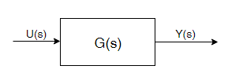
Figure 1. Open Loop Block Diagram

For our case, output (Y(s)) and input (U(s)) are defined as follows:
Y(s) = $\dot{θ}(s)$, speed of the motor
U(s), input voltage
G(s), open loop transfer function
Furthermore, assume that u(t) is a step input, i.e. constant in time. Then U(s) = Γ/s where Γ is constant. Consequently,
$$\dot{θ}\left(s\right)= \frac{Γ}{s} G(s)$$
By taking inverse Laplace transform of the above equation, we compute the speed in time:
$$\dot{θ}\left(t\right)=KΓ\left(1-e^{-\frac{t}{}}\right) (2)$$
Observe that equation (2) represents a constant term on top of a decaying exponential. As t goes to infinity, exponential part decays to zero, leaving constant KΓ term behind.

ii) Closed Loop Control
A generic closed loop control block diagram is given in figure 2.
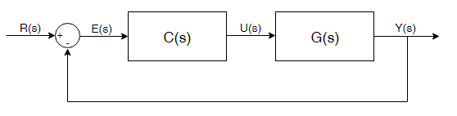
Figure 2. Closed Loop Block Diagram

In this case, R(s) is the reference input (reference speed)
E(s) error between reference R(s) and actual speed $\dot{θ}(s)$,
C(s) is the controller
U(s) is the input voltage
G(s) is the open loop transfer function computed in the previous section
Closed loop transfer function from $\dot{θ}(s)$ to R(s):
$$\frac{\dot{θ}(s)}{R(s)}=\frac{C(s)G(s)}{C(s)G(s)+1} (3)$$
To further elaborate equation (3), we need to choose an expression for C(s). We will investigate two forms of controller C(s). First is P control, second is PI control.
- Proportional (P) Control
P controller is given by C(s) = K_{P} (4).
In more pedagogical terms, proportional controller works as follows: we measure the discrepancy between actual and desired speed, which gives us the error and multiply it by a coefficient, K_{P}, and use this signal to drive the motor.
Plugging in the expressions for C(s) and G(s) using equations (1), (3) and (4) we compute the closed loop transfer function to be:
$$G_{P}\left(s\right)=\frac{\dot{θ}(s)}{R(s)}=\frac{K K_{P}}{s+K K_{P}+1}=\frac{K K_{P}}{K K_{P}+1} \frac{1}{\frac{}{K K_{P}+1}s+ 1} (5)$$

Note that closed loop transfer function is still of first order, so we expect an exponential response. But, DC gain and time constant now depend on the value of K_{P}, which implies that we can tune the response of the system by manipulating K_{P}.

- Proportional Integral (PI) Control
In this case, C(s) = K_{P} +K_{I} s (6).
Using (1), (3) and (6) we compute the closed loop transfer function to be:
$$G_{PI}\left(s\right)=\frac{\dot{θ}(s)}{R(s)}=\frac{\frac{K K_{P}}{}s+ \frac{K K_{I}}{}}{s^{2}+\frac{K K_{P}+1}{}s+ \frac{K K_{I}}{}} (7)$$
Note that the closed loop transfer function has become second order (due to s² term in the denominator). Standard form for second order transfer functions is given by:
$$\frac{{}_{n}^{2}}{s^{2}+2{}_{n}s+ {}_{n}^{2}}$$
which is not perfectly analogous to G_{PI}(s) due to $\frac{K K_{P}}{}s$ term in the nominator. But by agreeing to make some error, we can safely ignore this term and assume that G_{PI}(s) is in the standard second order transfer function form:
$$G_{PI}\left(s\right)=\frac{{}_{n}^{2}}{s^{2}+2{}_{n}s+ {}_{n}^{2}}\tilde{=}\frac{\frac{K K_{I}}{}}{s^{2}+\frac{K K_{P}+1}{}s+ \frac{K K_{I}}{}}$$
Due to higher degree of the transfer function, now we have richer dynamics compared to above (which was only exponential). The behavior is dominated by , damping ratio. Depending on the value of , 4 different qualitative behaviors may be observed.

II. Equipment

Hardware:
- Vernier Rotary Motion Motor Kit including:
  - Jameco RF-370CA-15370 DC Motor
  - Pulley
  - Rubber band belt
  - Motor clip
  - Mounting screw
- Vernier Rotary Motion Sensor
- Vernier SensorDaq
- Jumper Wires

Software:
- LabView

III. Experimental Procedure

Assemble is the system as seen in figure 3:
- Secure the clamp onto station
- Place rod into clamp and tighten so it does not move
- Place rotary motion sensor into rod
- Mount screw and clip to the sensor and belt to the sensor’s hoop
- Connect rotary motion sensor to SensorDaq DIG Port
- Connect two alligator clips between motor input jumper wires
- Connect jumper wires to SensorDaq pins 8 and 9

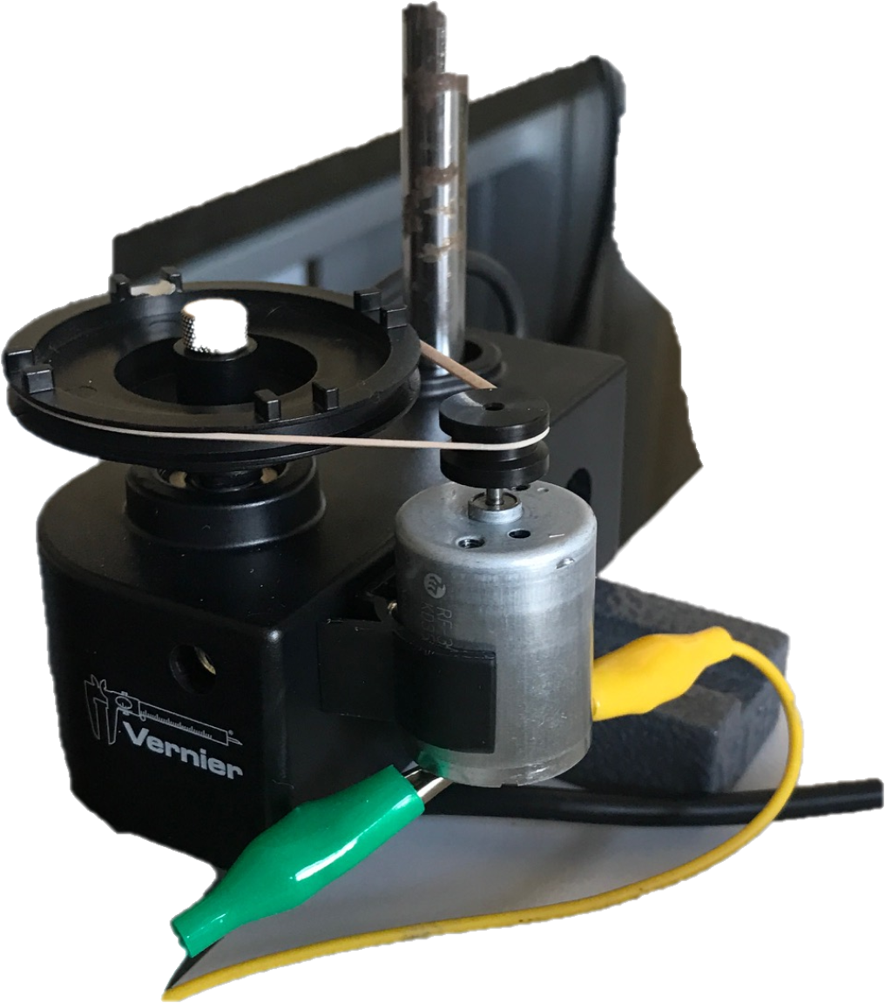

Figure 3. DC Motor Configuration

Part I – Open Loop Response

Open the LabView file “DCcontrol.vi”
Turn the open/closed loop knob into “Open Loop”
In the “Open Loop” tab below, adjust u to 3V.

If our assumptions and modelling are correct, according to theory (equation 2), you are expected to observe an exponential curve that converges to a constant value in t vs $\dot{θ}(t)$ graph. Validate this prediction by observing the shape of your graph.

Did you see an exponential graph?

Read the converged value from the graph and note it in the box below.

Speed for 3V : rad/s

Save your data into USB stick.

Part II – Closed Loop Response

In this section, we have a desired (reference) speed that we wish to achieve sooner or later. Hence, while performing the experiment, keep these two questions in mind related to desired speed:
- Does the system converge into the desired speed? (i.e. is there an error between actual and desired speed?)
- If yes, how will it converge to the desired speed? (i.e. how the transients behave)

Part IIa – P Control

Open the LabView file “DCcontrol.vi”
Turn the open/closed loop knob into “Closed Loop”.
In this part, we should pick a “desired speed” value to command into the system as reference (see figure 2). Suppose this value, r(t) = 140 rad/s, a step function. (In Laplace domain, R(s) is Laplace transform of step function which is R(s) = 140/s).
Adjust “Desired Speed” slider to 140 rad/s.

By looking at G_{P}(s) (equation 5), state if it is possible to converge to this speed value (use final value theorem in appendix).
Theoretically, is it possible to converge to reference?

Try different values of K_{P}. What happens to error when K_{P} is increased?
Theoretically, error decreases/increases when K_{P} is increased.

Now increase K_{P} in LabView in the interval [0.02 ; 0.04]. What happens to the error?
Experimentally, error decreases/increases when K_{P} is increased.

For three different values of K_{P}, fill in the table below. Note the steady state value and rise time

Table 1. P controller experiment data
Kp | Steady state value | Error | τ
0.02
0.03
0.04

Save all three sets of data into your USB stick.

Part IIb – PI Control

Open the LabView file “DCcontrol.mdl”
Turn the open/closed loop knob into “Closed Loop”.
Suppose r(t) = 140 rad/s. R(s) = 140/s. Adjust “Desired Speed” slider to 140 rad/s.
Adjust “Desired Speed” slider to 140 rad/s.

By looking at G_{PI}(s) (equation 7), state if it is possible to converge to this speed value (use final value theorem in appendix).
Theoretically, is it possible to converge to reference?

Set K_{P} to 0.025. Change K_{I} values in the interval [0.001 ; 0.004]. Do you notice any error?

Experimentally, is it possible to converge to reference?

For four different values of K_{I,LW} fill in the table below. Depending on the behavior you see on graphs, make a guess for damping ratio interval.

NB: In LabView, PI controller is defined as U(s) = K_{P} + K_{P} $\frac{s}{60 K_{I,LW}}$ instead of equation 6, where K_{I,LW} is the integral control gain (subscript LW represents LabView). Note the correspondence between these two integral gains are: K_{I} = $\frac{K_{P}}{60 K_{I,LW}}$
Save all four sets of data into your USB stick.

Table 1. PI controller experiment data
K_{I,LW} | Steady State Value | Oscillations? | Time to steady state | Damping Ratio Interval
0.001
0.002
0.003
0.004

IV. Assignments

Open loop:

Using data of part I:
- Plot t versus speed in Excel/Matlab
- Fit an exponential curve to the data (Hint: manipulate equation (2) so that it is of the form y = mx + b. Then, fit a linear equation to this new data set. You might take logarithms, other algebraic operations and apply change of variables.)
- Compute K and τ from the equation of the fit

Closed loop, P control:

Using data of part IIa:
- Plot 3 curves on top of each other showing behavior as K_{P} is increased. Comment considering convergence to steady state, steady state error etc.
- Compare theoretical expectations vs experimental outcomes using equations above and your data. State any error between theory and experiment, explain the possible sources of error.

Closed loop, PI control:

Using data of part IIb:

- Plot 4 curves on top of each other showing behavior as K_{I} is increased. Comment considering convergence to steady state, steady state error, transients and oscillations etc. Refer to second order system performance criteria (such as rise time, maximum overshoot etc.) if you need to.
- Compare theoretical expectations vs experimental outcomes using equations above and your data. State any error between theory and experiment, explain the possible sources of error.

References

- “DC Motor Speed: System Modeling”, accessed on 26.02.19 http://ctms.engin.umich.edu/CTMS/index.php?example=MotorSpeed&section=SystemModeling

Appendix. Final Value Theorem
In control theory, a useful theorem is “Final Value Theorem” which is used to compute final values of signals, hence its name. Mathematically it is defined as,
$$\lim_{s→0}{sF(s)} (10)$$
where F(s) is any signal in Laplace domain. In our case, we are interested in final values of two signals:
- Speed, $\dot{θ}(s)$ to check if it reaches desired speed value as time goes to infinity
- Error, E(s) to check if it goes to zero as time goes to infinity
For speed, set F(s) = $\dot{θ}(s)$ in equation (10): $$\lim_{s→0}{s\dot{θ}(s)}$$
$$\lim_{s→0}{sR(s)G_{P}(s)}$$
$$\lim_{s→0}{s\frac{Γ}{s}G_{P}(s)}$$
$$\lim_{s→0}{ΓG_{P}(s)}$$
For error, set F(s) = $E(s)$ in equation (10)
$$\lim_{s→0}{sE(s)}$$
$$\lim_{s→0}{s(R\left(s\right)-\dot{θ}(s))}$$
$$\lim_{s→0}{s(R\left(s\right)-R(s)G_{P}(s))}$$
$$\lim_{s→0}{s\frac{Γ}{s}(1-G_{P}(s)})$$
$$\lim_{s→∞}{Γ{(1-G}_{P}(s))}$$
These equations are given for closed loop transfer functions under P control. In case of PI control, simply replace G_{P}(s) by G_{PI}(s).

