** MARMARA UNIVERSITY**

**FACULTY OF ENGINEERING**

**DEPARTMENT OF MECHANICAL ENGINEERING**

**ME 4001 MECHANICAL ENGINEERING LABORATORY**

EXPERIMENT NO 1: **TENSILE TESTING of ENGINEERING MATERIALS**

1. **Objective**

The objective of this experiments is to load a tensile test sample at a constant crosshead speed until failure, while recording the value of the load and the change in length of the test sample at each stage. Then based on the collected data,

• The material’s stress-strain relationship is obtained.

• The following structural properties are determined: Modulus of elasticity, yield strength, ultimate tensile strength, yield strain, failure strength and strain to failure.

• The strain is measured with a video extensometer.

• The reduction of cross-sectional area of the tested sample is determined, if applicable.

1. **Introduction**

There are basically three types of strain measurements methods: mechanical, video and laser type extensometers. In this video type extensometers will be used to measure strain under a known load. Once the strain is measured, the flexural rigidity and modulus of elasticity of the beam can be calculated by using the well-known Hooke’s law and bending stress formulas.

1. **Theoretical background**

The mechanical properties of materials are determined by performing carefully designed laboratory experiments that replicate as nearly as possible the service conditions. In real life, there are many factors involved in the nature in which loads are applied on a material. The following are some common examples of modes in which loads might be applied: tensile, compressive, and shear. These properties are important in materials selections for mechanical design. Other factors that often complicate the design process include temperature and time factors.

The topic of this lab is confined to the tensile property of polymers. Figure 1 shows a tensile testing machine similar to the one used in this lab. This test is a destructive method, in which a specimen of a standard shape and dimensions (prepared according to *TS EN ISO 527*: standard test method for tensile properties of plastics) is subjected to an axial load. During a typical tensile experiment, a dog-bone shaped specimen is gripped at its two ends and is pulled to elongate at a determined speed to its breakpoint; a highly ductile polymer may not reach its breakpoint. The tensile tester used in this lab is manufactured by SHIMADZU (model AGS-X 50 kN).It has a maximum load of 50 kN and a variable crosshead speeds between 0.001 mm/min. and 800 mm/mm. The setup of the experiment could be changed to accommodate different types of mechanical testing, according to the ISO, EN or ASTM standards (e.g. tension, compression, bending test, etc).

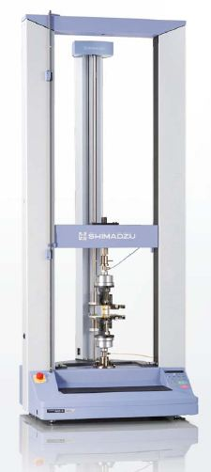

***Figure 1.***  *A photograph of a tensile machine SHIMADZU AGS-X 50 kN*

For analytical purposes, a plot of stress (σ) versus strain (ε) is constructed during a tensile test experiment, which can be done automatically on the software provided by the instrument manufacturer. Stress, in the metric system, is usually measured in N/m2 or Pa, such that 1 N/m2 = 1 Pa. From the experiment, the value of stress is calculated by dividing the amount of force (*F*) applied by the machine in the axial direction by its cross-sectional area (*A*), which is measured prior to running the experiment. Mathematically, it is expressed in Equation 1. The strain values, which have no units, can be calculated using Equation 2, where *L* is the instantaneous length of the specimen and *L0* is the initial length.

 (1)

 (2)

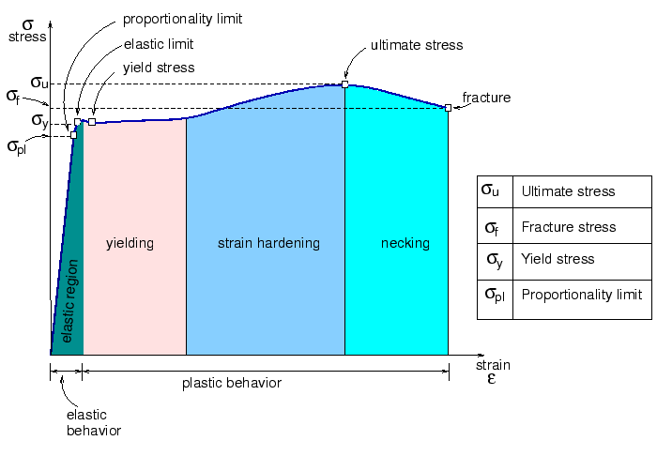

***Figure 2.*** *Various regions and points on the stress-strain curve.*

A typical stress-strain curve would look like as in Figure 2. The stress-strain curve shown in Figure 2is a textbook example of a stress-strain curve. In reality, not all stress-strain curves perfectly resemble the one shown in Figure 2. This stress-strain curve is typical for ductile metallic elements. Another thing to take note is that Figure 2 shows an “*engineering stress-strain*” curve. When a material reaches its *ultimate stress strength* of the stress-strain curve, its cross-sectional area reduces dramatically, a term known as *necking*. When the computer software plots the stress-strain curve, it assumes that the cross sectional area stays constant throughout the experiment, even during necking, therefore causing the curve to slope down. The “true” stress-strain curve could be constructed directly by installing a “gauge,” which measures the change in the cross sectional area of the specimen throughout the experiment.

Theoretically, even without measuring the cross-sectional area of the specimen during the tensile experiment, the “true” stress-strain curve could still be constructed by assuming that the volume of the material stays the same. Using this concept, both the true stress (*σT*) and the true strain (*εT*) could be calculated using Equations 3 and 4, respectively. The derivation of these equations is beyond the scope of this lab report. Consult any standard mechanics textbook to learn more about these equations. In these equations, *L0* refers to the initial length of the specimen, *L* refers to the instantaneous length and *σ* refers to the instantaneous stress.

 (3)

 (4)

Figure 2 also shows that a stress-strain curve is divided into four regions: elastic, yielding, strain hardening (commonly occurs in metallic materials), and necking. The area under the curve represents the amount of energy needed to accomplish each of these “events.” The total area under the curve (up to the point of fracture) is also known as the *modulus of toughness*. This represents the amount of energy needed to break the sample, which could be compared to the impact energy of the sample, determined from *impact tests*. The area under the linear region of the curve is known as the *modulus of resilience*. This represents the minimum amount of energy needed to deform the sample.

The linear region of the curve of Figure 2*,* which is called the elastic region (past this region, is called the plastic region), is the region where a material behaves elastically. The material will return to its original shape when a force is released while the material is in its elastic region. The slope of the curve, which can be calculated using Equation 5, is a constant and is an intrinsic property of a material known as the elastic modulus, *E*. In metric units, it is usually expressed in Pascals (Pa).

 (5)

Figure 3(a) shows typical stress-strain curves of polymers. The figure shows that materials that are hard and brittle do not deform very much before breaking and have very steep elastic moduli.

The mechanical property of polymers generally depends on their degree of crystallinity, molecular weights and glass transition temperature, *Tg*. Highly crystalline polymeric materials with a *Tg* above the room temperature are usually brittle, and vice versa. When a semi-crystalline polymer undergoes a tensile test, the amorphous chains, will become aligned. This is usually evident for transparent and translucent materials, which become opaque upon turning crystalline. Figure 3(b) shows a diagram showing the mechanical property of some common polymers.

(b)

(a)

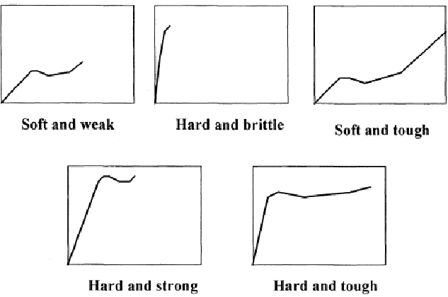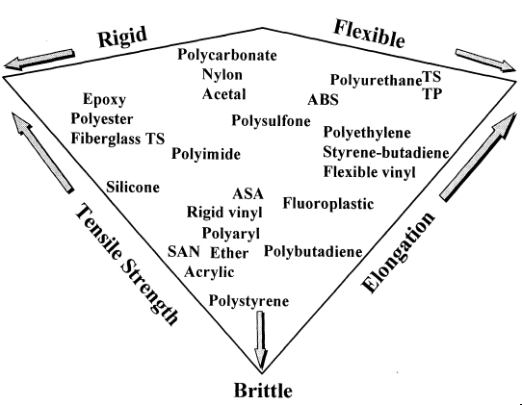

***Figure 3.***  *(a) A plot of stress-strain curves of typical polymeric materials. (b) A summary diagram of the properties of common polymers.*

1. **Apparatus:**

The following apparatus will be used through the experiment.

* + Universal Testing Machine (SHIMADZU AGS-X 50 kN)
  + Computer with TRAPEZIUM Software
  + Video Extensometer
  + Vernier Caliper
  + Permanent marker

1. **Materials:**

Flat (or Circular) plastic or steel with various dimensions could be used. In the experiment High Density Polyethylene (HDPE) polymer samples will be tested for tensile test properties.

1. **Experimental procedure**

***Important!*** Make sure you stay away from the test equipment and if possible use safety glasses before starting any operation. Your eyes could be hurt by a broken piece of polymer. Also wear gloves to protect against any residue on the machine and samples.

# 6.1 Specimen Preparation

The polymer specimens were cut into dog-bone shapes. Their dimensions were determined according to the *TS ISO EN 527* standard mentioned earlier in the introduction.

(1) Measure the thickness, width and gage length of polymer samples in mm. These dimensions should be approximately the same for each sample.

(2) Also make note of any sample defects (e.g. impurities, air bubbles, etc.).

High density polyethylene (HDPE) polymer samples will be tested for tensile test properties.

# 6.2 TRAPEZIUM X Materials Testing Software Setup

1) Turn on the tensile test machine. The switch is located on the right side of the machine. Also turn on the video extensometer.

(2) Go to the desktop and double-click on the “TRAPEZIUM” icon.

(3) On the main page, select Testto start a new sample. Name your test and click Browse to select the folder you would like to save it in. Click next.

(4) Choose which method you would like to use. Create and save a new method if needed.

(5) Method set up: Save after any changes are made.

* Specimen: specifies sample dimensions and parameters. A dog-bone sample is used for tensile testing. Select rectangular, and specify the width, thickness and gauge length of the sample. The gauge length is the distance between the clamps before starting the test.
* Control: describes the actual test. Select extension for mode of displacement, then specify the rate of extension. Most use 5 mm/min or 50 min/mm, depending on if you want a slow or fast test.
* End of Test: identifies the criteria for the end of the test. A large load drop is experienced when sample failure occurs. For this test, when the sample load drops by a certain percentage of the peak load, the machine will stop.
* Data: specifies if the data is acquired manually or automatically, while the strain tab recognizes whether the strain is measured from the video extensimeter or the extension.
* Results and Graphs: select what data is shown and how it is displayed.
* Measure and record the distance *d*, beam thickness *h* and beam width *b*.
* Apply the given known load to the beam.
* Measure and record the voltage output of the bridge.

(1) Make sure the proper load cell is installed, either 2 kN or 50 kN depending on the load range and sensitivity of the sample. To switch load cells, make sure the machine is off. Unscrew the bolts and remove using the handle. Make sure to plug the new load cell into the port behind the machine.

(2) Calibrate the load cell by clicking on the button in the upper right hand corner. Make sure all loads are removed from the load cell and click calibrate.

(3) Install the correct type of clamps for the testing. For tensile testing, 5kN or 50kN samples can be used. Install the clamps using the pins. Also install height brackets if needed. Zero the load once the clamps are installed.

(4) Press the up and down arrows on the controller until the clamps are just touching**.** Press the reset gauge length button at the top of the screen to zero the position of the clamps.

(5)Use the up and down arrows until the clamps are about 100 mm apart. This is a typical gauge length for the dog bone samples.

(6) Place the polymer sample between the grips of both the tensile test machine. While holding the sample vertically with one hand, use another hand to turn the handle of the top grip in the closing direction as tightly as possible.

(7) The specimen should be gripped such that the two ends of the specimen are covered by the grip, approximately 3 mm away from its gage-length. It is important that the specimens are tightly gripped onto the specimen grips to prevent slipping, which will otherwise result in experimental errors. )

(8) Make sure that the specimen is vertically aligned, if not a torsional force, rather than axial force, will result.

(9) Turn the bottom handle in the “close” direction as tightly as possible. Visually verify that the sample is gripped symmetrically at its two ends.

(10)Zero the extension by pushing zero extension button at the top of the screen. Also zero the load if needed. Wait for a few seconds to let the computer return its value to zero.

# 6.4 Tensile Test

(1) Enter geometry of the sample before starting.

(2) Click on the Start button. Both the upper and bottom grips will start moving in opposite directions according to the specified pulling rate. Observe the experiment at a safe distance (about 1.5 meters away) at an angle and take note of the failure mode when the specimen fails.

(NOTE: Be sure to wear safety glasses. Do not come close to equipment when the tensile test is running).

(3) A plot of tensile stress (MPa) versus tensile strain (mm/mm) will be generated in real-time during the experiment.

# 6.5 End of Test

(1) The machine will stop automatically when the sample is broken.

(2) Press the “Return” button on the digital controller. Both the upper and lower grips will be returned to their original positions automatically.

(3) Turn the two handles in the open directions to remove the sample

(4) Repeat the previous steps for any additional tests.

(5)When finished, save your file and click Finish. This will export your data into a PDF and individual data files.

(6) Clean up any broken fragments from the specimens.

(7) Turn off the machine and exit the program when finished.

1. **Required calculations**

Measure and calculate the parameters in Table 1.

***Table 1:*** *Test parameters and test results of instrumented Charpy impact tests* 

1. **Required report format**

* The report should be organized as follows: Title Page, Introduction, Theoretical Background and Calculations, Discussions, Conclusion, Appendix (if any).
* Measured and calculated quantities should be presented in tabular form.
* Show all details of your calculations.
* Discuss the possible sources of errors.
* Make recommendations for improving the experimental procedure.

**References**

1. Callister, W. D., & Rethwisch, D. G. (2011). *Materials science and engineering: An Introduction*, 8th Edition, John Wiley & Sons.

2. Collins, J. A. (1993). *Failure of materials in mechanical design: analysis, prediction, prevention*. John Wiley & Sons.

3. *ASM Metals Handbook*, Vol. 10, 8th Ed., p. 102

5. Dieter, G.E., (1988) *Mechanical Metallurgy,* SI Metric edition, New York (Chap. 12)

5. TS EN ISO 179-2. Plastics-Determination of tensile properties-Part 2: Test conditions for moulding and extrusion plastics

# PREPARING LABORATORY REPORTS

The following guideline is to be used to prepare laboratory reports.

1. **Title:** This section contains the title of the test, the nature of the test and the specification number used.
2. **Scope of the test:** A brief statement of the purpose and significance of the test should be indicated.
3. **Apparatus:** Equipment used should be briefly described.
4. **Materials:** The materials used or tested should be described.
5. **Theory:** This section summarizes the test/experiment or it gives us an overview of what the test is all about.
6. **Definitions and Process Terminology:** This section contains terminology and definition of specific words and test related terms.
7. **Procedure:** Clearly and concisely list the procedure in the order the test is carried out.
8. **Raw Data:** This section contains the raw data gotten from the test. All laboratory data shall be submitted in tabular form.
9. **Calculations and Results:** Observations relating to the behaviour of the materials should be included. All equations or formulas used should be clearly indicated. Calculations should be properly checked. The results of the test should be summarized in tabular or graphical form.
10. **Figures and Diagrams:** This section contains clear and concise diagrams and/or figures in accordance with the laboratory requirement. Figures including the equipment front and side views, parts and panels can be displayed in this section.
11. **Discussion:** There should be included a brief discussion in which attention is drawn to the silent facts shown by the tables and diagrams. The test results should be compared with the standard values.
12. **Conclusion:** Include modification procedures, calibration procedures and any additional information that will be helpful.
13. **References (if applicable):** Include references to any manuals, documents or textbooks used in compiling the reports.