**MARMARA UNIVERSITY**

**FACULTY OF ENGINEERING**

**DEPARTMENT OF MECHANICAL ENGINEERING**

**ME 4001 MECHANICAL ENGINEERING LABORATORY**

EXPERIMENT NO. 2: **CHARPY IMPACT TESTING of ENGINEERING MATERIALS**

1. **Objective**

To conduct instrumented Charpy V-notch impact test and determine the Charpy impact resistance of engineering materials..

1. **Equipment**

* Standard Charpy V-Notched Test specimens
* Impact tester
* Computer
* Vernier Caliper

1. **Introduction**

Notched-bar impact test of metals provides information on failure mode under high velocity loading conditions leading sudden fracture where a sharp stress raiser (notch) is present. The energy absorbed at fracture is generally related to the area under the stress-strain curve which is termed as toughness in some references. Brittle materials have a small area under the stress-strain curve (due to its limited toughness) and as a result, little energy is absorbed during impact failure. As plastic deformation capability of the materials (ductility) increases, the area under the curve also increases and absorbed energy and respectively toughness increase. Similar characteristics can be seen on the fracture surfaces of broken specimens. The fracture surfaces for low energy impact failures, indicating brittle behaviour, are relatively smooth and have crystalline appearance in the metals. On the contrary, those for high energy fractures have regions of shear where the fracture surface is inclined about 45° to the tensile stress, and have rougher and more highly deformed appearance, called fibrous fracture. Although two standardized tests, the Charpy and Izod, were designed and used extensively to measure the impact energy, Charpy v-notched impact tests are more common in practice. The apparatus for performing impact tests is illustrated schematically in Figure-I. The load is applied as an impact blow from a weighted pendulum hammer that is released from a position at a fixed height *h.* The specimen is positioned at the base and with the release of pendulum, which has a knife edge, strikes and fractures the specimen at the notch. The pendulum continues its swing, rising a maximum height *h* ' which should be lower than *h* naturally. The energy absorbed at fracture *E* can be obtained by simply calculating the difference in potential energy of the pendulum before and after the test such as,

*E* = *m.g.(h-h* ') (1)

where *m* is the mass of pendulum and *g* is the gravitational acceleration. The geometry of 55 mm long, standard Charpy test specimen is given in Figure-2. If the dimensions of specimens are maintained as indicated in standards, notched-bar impact test results are affected by the lattice type of materials, testing temperature, thermo-mechanical history, chemical composition of materials, degree of strain hardening, etc.

Charpy impact strength (CVN) is then calculated from equation 2.

 (1)

Where E is the absolved energy (Joule), B is the depth (mm), a is the notch length (mm) and t is the thickness of the test sample.

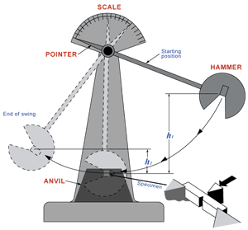

***Figure 1:*** *Apparatus for impact testing of materials.*

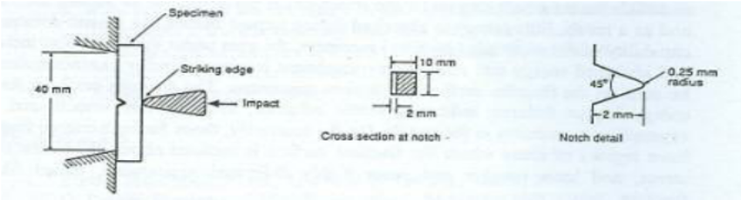

***Figure 2:*** *Specimen and loading configuration for Charpy V-notched impact test.*

Body cantered cubic (bcc) metals, particularly steels, often exhibit a decrease in impact energy as the temperature is lowered. The temperature at which a sharp decrease in impact energy occurs is called the ductile-brittle transition temperature (DBTT) as shown in Figure-3 schematically. This transition temperature is generally chosen as a lower limit for the application of such metals. Some steels may show transition characteristics in their failure mode from ductile to brittle gradually as temperature is decreased, which is given in Figure-4 schematically. In this case different approaches may be used in determining transition temperature but the average energy concept is the most popular one. Determination of transition temperature can also be done by examining the fracture surfaces of specimens tested at different temperatures. For example the temperature, at which the fracture surface consists 50 percent cleavage (crystalline) and 50 percent ductile (fibrous) types of fracture, is called fracture appearance transition temperature (FATT). Another common criterion is to determine the transition temperature on the basis of an arbitrary energy absorbed. For example *20 J transition temperature* is an accepted criterion for low-strength ship steels.

[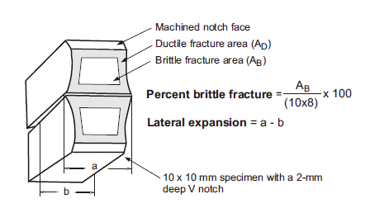](http://www.google.com/url?sa=i&rct=j&q=&esrc=s&source=imgres&cd=&cad=rja&uact=8&ved=2ahUKEwiynZiDtNbeAhVEzKQKHVPKC_4QjRx6BAgBEAU&url=http%3A%2F%2Fwww.kobelco-welding.jp%2Feducation-center%2Fabc%2FABC_2008-04.html&psig=AOvVaw13A2QiLaot9IL0fTWn8njN&ust=1542371581356827)

***Figure 3:*** *Schematic of a fracture surface of broken Charpy .impact sample*



***Figure 4:*** *Various criteria of transition temperature obtained from Charpy tests (Dieter, 2008)*

The ordinary Charpy test measures the total energy absorbed in fracturing the specimen. Additional information can be obtained if the impact tester is instrumented to provide a load-time history of the specimen during the test. Figure 3 shows an idealized load-time curve for an instrumented Charpy test. With this kind of record it is possible to determine the energy required for initiating fracture and the energy required for propagating fracture. It also yields information on the load for general yielding, the maximum load, and the fracture load (Dieter, 1988).

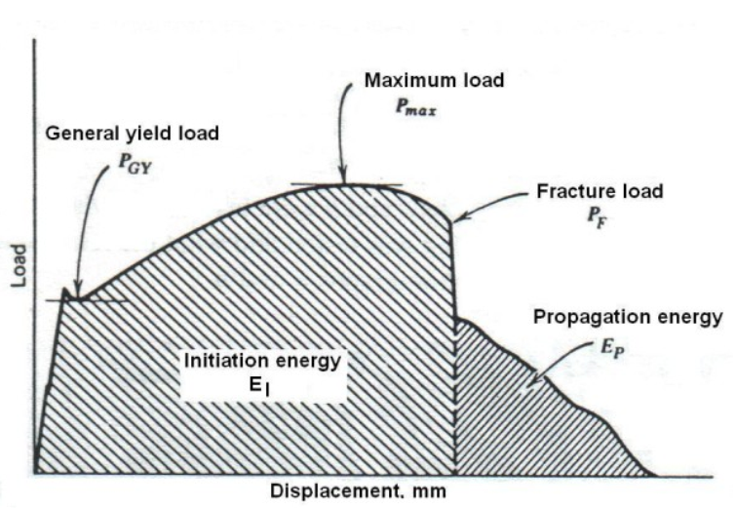

***Figure 5:*** *Load-time history for an Instrumented Charpy test (Dieter, 2008)*

**Procedure**

Note: Test one material with three specimens at room temperature. High density polyethylene (HDPE) will be used in the experiment. The samples were die-cut from a pipe.

1. Check the zero calibration of the impact tester.

2. Check and record the test environment humidity and temperature.

3. Measure the test samples dimensions.

4. Introduce a sharp notch to the test sample a stated in test standard.

5. Note fracture energy and estimate the % brittleness from the appearances of fracture surfaces of the specimens.

**Lab Report Requirements**

1. Results

* Display and calculate the parameters in a Table 1.
* Plot impact energy versus time
* Plot the impact force versus time.
* A couple of fracture surface pictures showing major fracture features

2. Discussion *(the questions will be answered in the lab report)*

2.1. Suggest 2 ways by which Cv can be lowered.

2.2. What are the 3 basic factors which contribute to brittle fracture of tested material(s) ? Do all 3 have to be present for brittle fracture to occur?

2.3. Explain how a triaxial stress state can arise at the root of a notch. Would this occur in thick or thin material? Thus, when does a biaxial stress state occur?

2.4. What are the main uses of the Charpy test?

2.5. List the ASTM and TS specifications for the two impact tests with titles.

2.6. Explain the relation between fracture toughness (KIC) of steels and Charpy impact energy.

2.7. Explain the effect of temperature on transition behaviour of tested material.

Table 1. Test parameters and test results of instrumented Charpy impact tests



**References**

1. *Metals Handbook,* 9th ed., *Mechanical Testing,* Vol. 8, 1990.

2. Dieter, G.E., (1988) *Mechanical Metallurgy,* SI Metric edition, New York

3. N. Dowling, *Mechanical Behaviour of Materials,* Prentice Hall, 1993.

4. TS EN ISO 179-2. Plastics – Determination of Charpy impact properties – Part 2: Instrumented impact test

5. *ASM Metals Handbook*, 9th ed. Vol. 12

# PREPARING LABORATORY REPORTS

The following guideline is to be used to prepare laboratory reports.

1. **Title:** This section contains the title of the test, the nature of the test and the specification number used.
2. **Scope of the test:** A brief statement of the purpose and significance of the test should be indicated.
3. **Apparatus:** Equipment used should be briefly described.
4. **Materials:** The materials used or tested should be described.
5. **Theory:** This section summarizes the test/experiment or it gives us an overview of what the test is all about.
6. **Definitions and Process Terminology:** This section contains terminology and definition of specific words and test related terms.
7. **Procedure:** Clearly and concisely list the procedure in the order the test is carried out.
8. **Raw Data:** This section contains the raw data gotten from the test. All laboratory data shall be submitted in tabular form.
9. **Calculations and Results:** Observations relating to the behaviour of the materials should be included. All equations or formulas used should be clearly indicated. Calculations should be properly checked. The results of the test should be summarized in tabular or graphical form.
10. **Figures and Diagrams:** This section contains clear and concise diagrams and/or figures in accordance with the laboratory requirement. Figures including the equipment front and side views, parts and panels can be displayed in this section.
11. **Discussion:** There should be included a brief discussion in which attention is drawn to the silent facts shown by the tables and diagrams. The test results should be compared with the standard values.
12. **Conclusion:** Include modification procedures, calibration procedures and any additional information that will be helpful.
13. **References (if applicable):** Include references to any manuals, documents or textbooks used in compiling the reports.